Project Requirements & Project Plan

Katherine Galvin, Ryan Buckmaster and Maureen O’Malley

University of Maryland Global Campus

CMSC 495 6380 Current Trends and Projects in Computer Science

Group 4

Revision 3

31 May 2022

**Revision History Table**

|  |  |  |  |
| --- | --- | --- | --- |
| **Revision Number** | **Date** | **Description** | **Name** |
| 1 | 5/22/2022 | Created the Document with basic details | Maureen O’Malley |
| 2 | 5/22/2022 | Added various Requirements | Ryan Buckmaster |
| 3 | 5/22/2022 | Added sections according to rubric such as functional requirements table and project schedule | Maureen O’Malley |
|  |  |  |  |
|  |  |  |  |
|  |  |  |  |
|  |  |  |  |

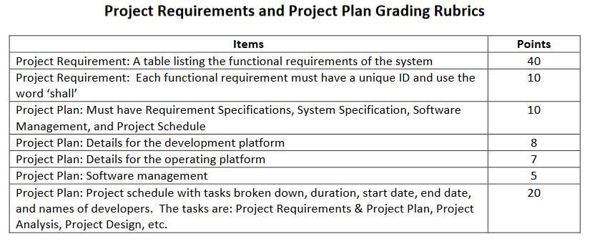

**This version is outdated. Please use the documents in the Microsoft Groups chat files.

Project Requirements (do not edit as changes should be in Microsoft Groups chat files):

<https://umuc365-my.sharepoint.com/:w:/g/personal/momalley8_student_umgc_edu/Ednuh9JV-c1FnltUBB_QunMBTIKQLhMA6gtp2zmx7kPrVw?e=m0ydg2>

Project Plan (do not edit as changes should be in Microsoft Groups chat files):

<https://umuc365-my.sharepoint.com/:w:/g/personal/momalley8_student_umgc_edu/EYaSHHcyKodKj80zbQtVEqQBk7JyFnUJ33fKG5qhzP6hHQ?e=nEj2Xd>

**Requirements Specification**

The purpose of this project is to create a library management system that allows the user to register, to check out books, and to renew books. The program will use a graphical user interface to generate registration and login pages. The authentication information will be stored in a separate location and hashed for increased security. The user information and book information will be stored using a Glassfish server and SQL databases. The following table lists the functional requirements of the system.

|  |  |
| --- | --- |
| **Requirement ID** | **Requirement Description** |
| R001 | Shall implement a registration page to take user input for a username and password. |
| R002 | Shall implement a login page to allow a registered user to sign in with their established credentials. The authentication should only succeed if the user has an account already registered. |
| R003 | Shall implement a GUI which includes text fields for the username and password and buttons for registration, login, and clearing out the text fields if needed. |
| R004 | Shall utilize an SQL database to specify which accounts have elevated privileges and only allow those admin accounts to make changes to the database records as needed, such as adding, modifying, or deleting books/user information. |
| R005 | Shall store user credentials in a separate file location and hash passwords for additional security. |
| R006 | Shall include both user and book information in the SQL database. For the books, the database should store the title, year of release, and author. For users, it should store the username, password(hashed), any outstanding fines attached to that account, and any books currently rented out by that user. |

Possible Requirements to address:

* The program will need a registration page to take user input for a username and password. This will represent the user’s account being added to the system.
* The program will then need a login page to allow a registered user to sign in with their established credentials. This authentication should only succeed if the user has an account already registered.
* The GUI should include text fields for the username and password. It should also include buttons for registration, login, and clearing out the text fields if needed.
* The SQL database should specify which accounts have elevated privileges and only allow those admin accounts to make changes to the database records as needed, such as adding, modifying, or deleting books/user information.
* The user credentials should be stored in a separate file location and, in the case of the passwords, hashed for additional security.
* The SQL database should include both user and book information. For the books, the database should store the title, year of release, and author. For users, it should store the username, password(hashed), any outstanding fines attached to that account, and perhaps any books currently rented out by that user.

**System Specification**

*Hardware and Software base for your project. A PC with JDK 6.0 is reasonable, but you might add more details, or make other selections, as appropriate.*

* A personal computer with JDK 6.0.

**Development Platform**

**Operating Platform**

**Software Management**

* Developers will use Netbeans IDE and IntelliJ IDE

**Project Schedule**

|  |  |  |  |  |
| --- | --- | --- | --- | --- |
| **Task** | **Duration** | **Start Date** | **End Date** | **Developers** |
| Project Requirements & Project Plan Document | 7 days | 5/24/22 | 5/31/22 | Katherine Galvin, Ryan Buckmaster and Maureen O’Malley |
| Project Analysis Document | 7 days | 5/31/22 | 6/7/22 | Katherine Galvin, Ryan Buckmaster and Maureen O’Malley |
| Project Design Document | 7 days | 6/7/22 | 6/14/22 | Katherine Galvin, Ryan Buckmaster and Maureen O’Malley |
| Project Test Plan & ICD Document | 7 days | 6/14/22 | 6/21/22 | Katherine Galvin, Ryan Buckmaster and Maureen O’Malley |
| Sprint 1 Individual Tasks | 7 days | 6/21/22 | 6/28/22 | Katherine Galvin, Ryan Buckmaster and Maureen O’Malley |
| Sprint 2 Individual Tasks | 7 days | 6/28/22 | 7/5/22 | Katherine Galvin, Ryan Buckmaster and Maureen O’Malley |
| Final source code and executables | 4 days | 7/5/22 | 7/9/22 |  |
| Test Case Screenshots for Final Delivery Document | 5 days | 7/5/22 | 7/10/22 |  |
| User’s Guide for Final Delivery Document | 5 days | 7/5/22 | 7/10/22 |  |
| All documents updated for Final Delivery Document | 5 days | 7/5/22 | 7/10/22 |  |
| Final Delivery Document (Post early enough so group members have time to reply as discussion closes on 7/10/22) | 5 days | 7/5/22 | 7/10/22 | Katherine Galvin, Ryan Buckmaster and Maureen O’Malley |